Government Engineering College, Thrissur
CS333– Application Software Development Lab
Documentation -
Exp 14 – Creation of Packages
Exp 15 – Creation of database
Triggers and Cursors

Date of Submission
26 October 2020

Submitted By
Kowsik Nandagopan D
Roll No 31
TCR18CS031
GECT CSE S5

Experiment 14

AIM
Creation of Packages

Description
Mysql supports stored procedures - the namespace of this is at the database level - there is no explicit support for creating namespaces at a lower level, and the '. ' scope operator seeprates databases and objects. So there is no equivalent entity in MySQL to an Oracle package

Experiment 15

AIM
Creation of database Triggers and Cursors

Description
Implement Creation of database Triggers and Cursors in MySQL to get valuable insight from the previously created database.
A trigger is a named database object that is associated with a table, and that activates when a particular event occurs for the table. Some uses for triggers are to perform checks of values to be inserted into a table or to perform calculations on values involved in an update. We can use triggers along with INSERT, UPDATE, and DELETE. We cannot apply triggers on MySQL views
A cursor allows you to iterate a set of rows returned by a query and process each row individually. MySQL cursor is read-only, non-scrollable and asensitive. You cannot fetch rows in the reversed order. In addition, you cannot skip rows or jump to a specific row in the result set.We have to create cursor(declare) → Set not found handler → Open Cursor → Loop using Fetch → Close Cursor.

Output / Screenshots
1. Trigger
1. Before Insert
- Trigger to check the currently entered percentage completed on project transaction is less than or equal to the previously entered value
- If the trigger is true it will signal the error to the screen and prevents the data to be entered to the database
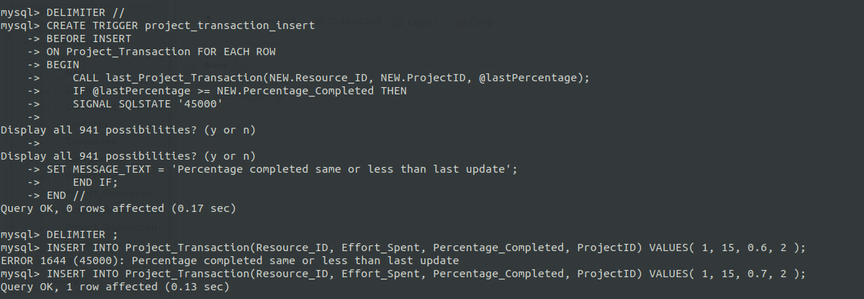
2. After Insert
- Create a trigger to update the project resource table to update actual efforts when we insert the new project transaction
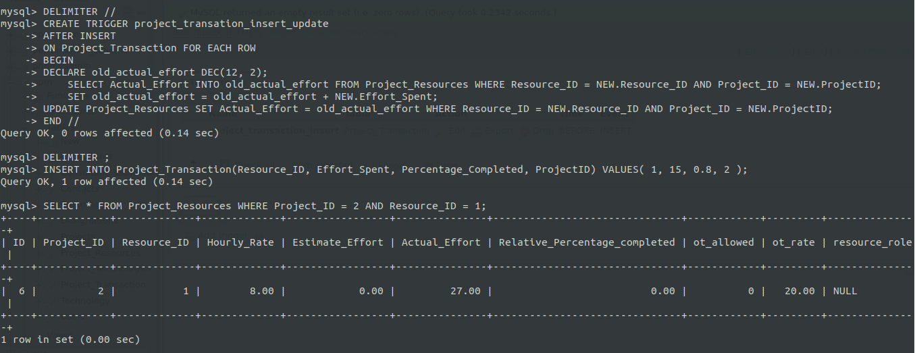
2. Cursor
Compute the whole effort spent per project from project transaction

